AI ASSISTED CODING
ASSIGNMENT-14
NAME: M. SAI SAMHITHA
ROLL NO: 2503A51L52
Task 1: AI-Assisted Portfolio Website
Scenario:
A student wants to showcase their projects, skills, and contact details in
a portfolio website. Instead of writing all code manually, they want to
speed up the process using GitHub Copilot.
• Use Copilot to generate an HTML structure for a personal
portfolio page (sections: Home, About, Projects, Contact).
• Ask Copilot to suggest responsive CSS styling for the layout
(e.g., grid/flexbox).
• Customize Copilot’s suggestions to add a hover effect on project
cards
PROMPT:
generate an HTML structure for a personal portfolio page (sections: Home, About, Projects, Contact).suggest responsive CSS styling for the layout (e.g., grid/flexbox).
add a hover effect on project cards give html css in same file

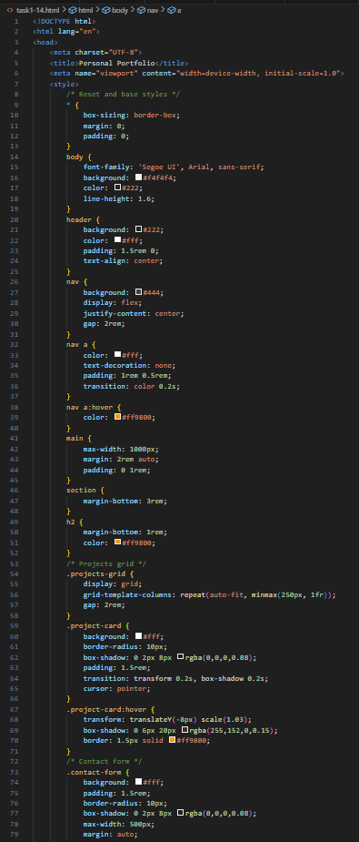

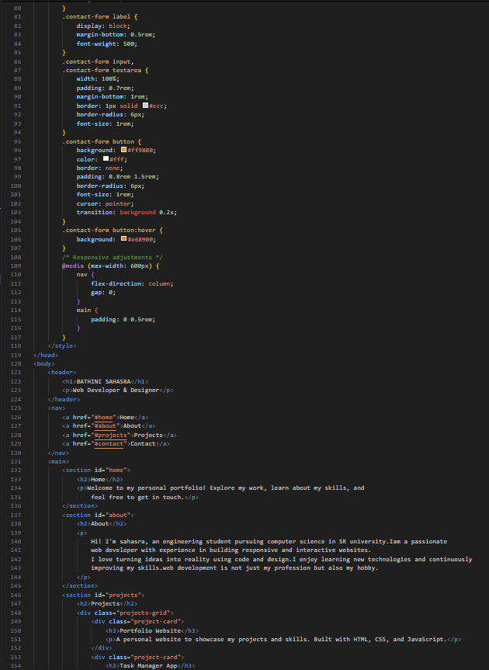
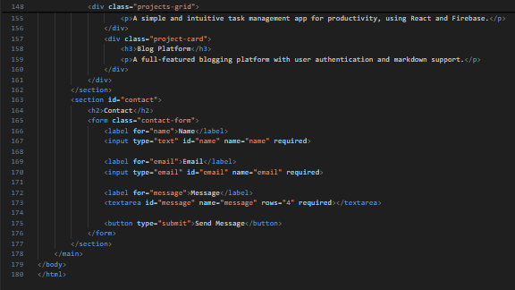

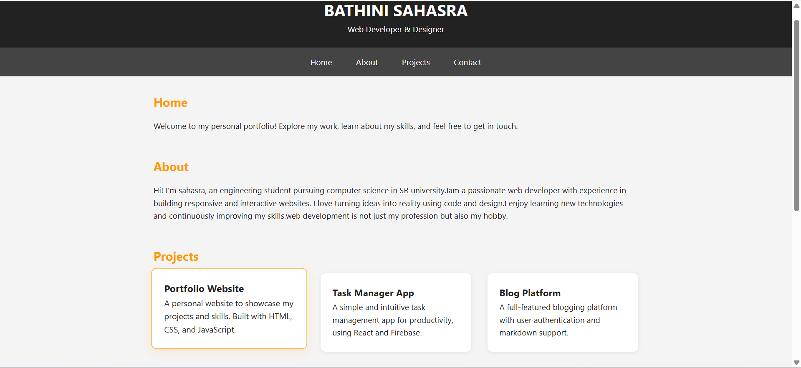


OBSERVATION:
The code builds a responsive personal portfolio webpage with four main sections: Home, About, Projects, and Contact. It uses flexbox and CSS grid for layout, ensuring adaptability across screen sizes. The navigation is sticky, the project cards include a hover effect (lift + shadow), and a simple contact form is provided, making the design clean, modern, and user-friendly.
Task 2: AI-Generated Restaurant Landing Page
Scenario:
A local restaurant needs a simple landing page with a navigation bar,
menu highlights, and an image gallery. The developer wants to quickly
generate it using AI assistance.
• Use Copilot to create a navigation bar with links (Home, Menu, Gallery, Contact).
• Generate a menu section styled with CSS cards.
• Add a JavaScript-based image slider for the gallery, with
Copilot suggesting the base code
PROMPT:
a local restaurant needs a simple landing page with a navigation bar,
menu highlights, and an image gallery.
•create a navigation bar with links (home, menu,
gallery, contact).
• generate a menu section styled with css cards.
• add a javascript-based image slider for the gallery, give all three codes in a single file
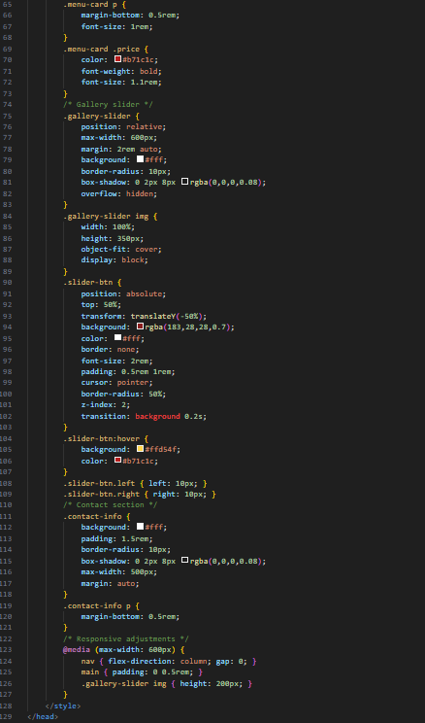
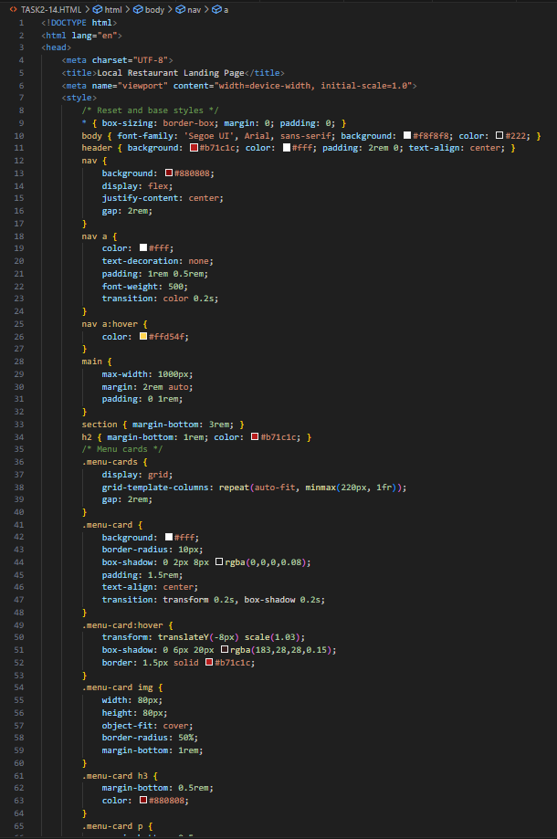
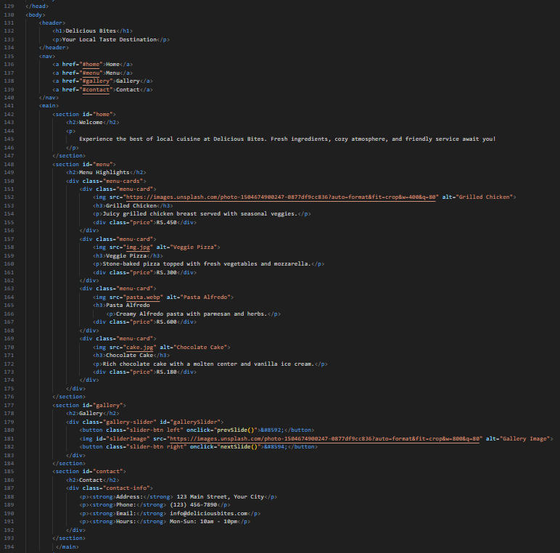

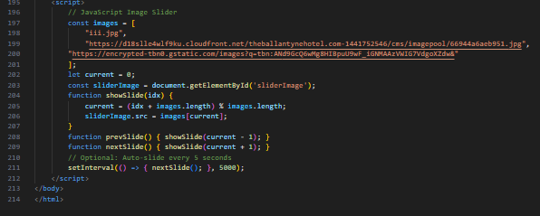
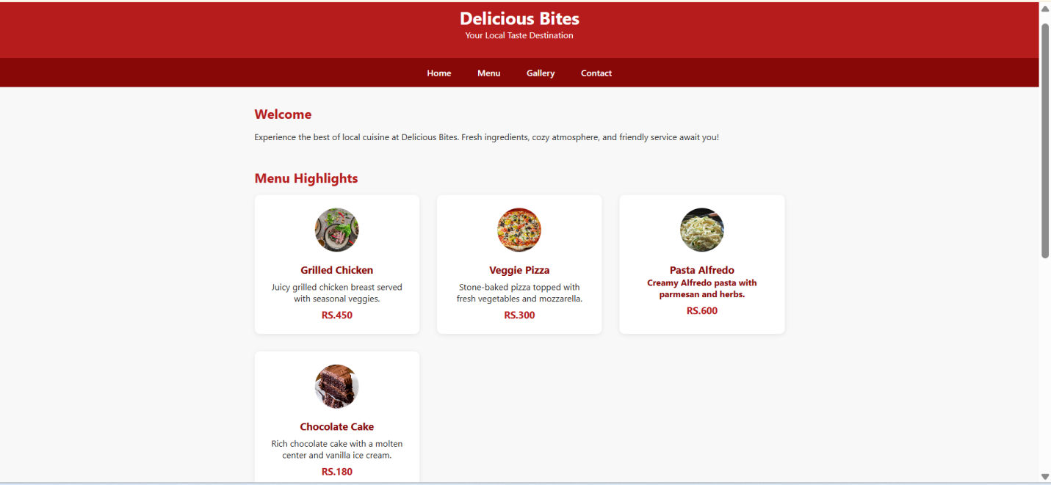

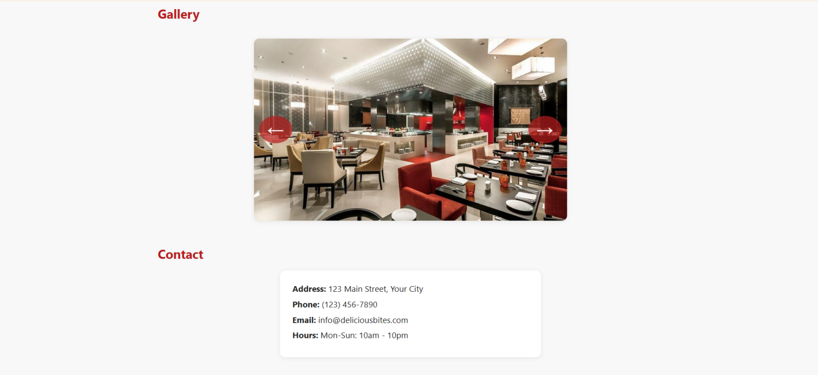
Observation:
The code designs a simple and responsive restaurant landing page with a sticky navigation bar, a menu section styled using CSS cards, and an interactive JavaScript-based image slider for the gallery. The layout is clean, user-friendly, and effectively highlights the restaurant’s offerings while ensuring easy navigation.

Task 3: AI-Powered Event Registration Form
Scenario:
SR University is hosting a tech fest. They need a web-based registration
form for students. The form must validate user input in real-time.
• Ask Copilot to generate an HTML form (fields: Name, Email,
Phone, Department, Event Selection).
• Use Copilot to assist in adding CSS styling for an attractive form
layout.
• Implement JavaScript validation (e.g., email format check,
phone number length check) using Copilot’s suggestions.
PROMPT:
SR University is hosting a tech fest. They need a web-based registration
form for students. The form must validate user input in real-time.
• generate an HTML form (fields: Name, Email,
Phone, Department, Event Selection).
• assist in adding CSS styling for an attractive form
layout.
• Implement JavaScript validation (e.g., email format check,
phone number length check) using Copilot’s suggestions. Give js html css in single file

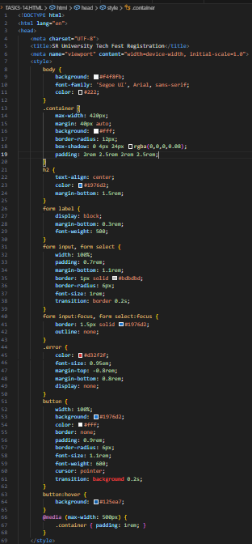
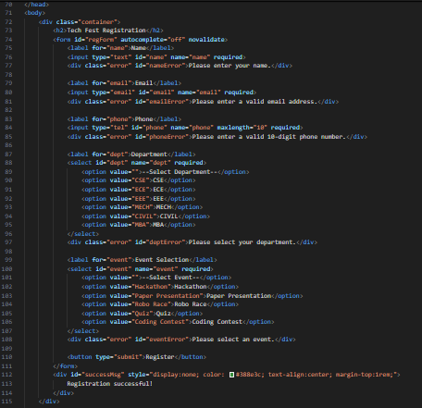
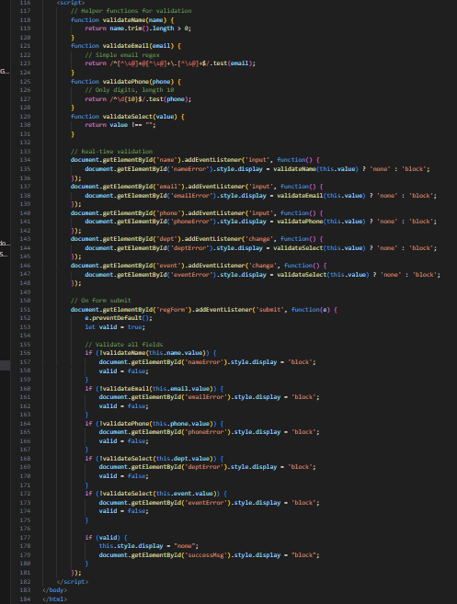

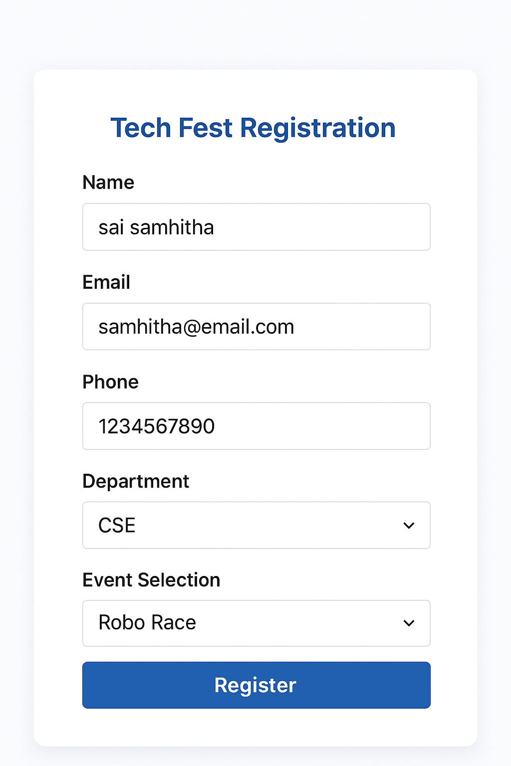
OUTPUT:



Observation:
The code provides a modern, responsive registration form with fields for student details and event selection. It uses CSS for an attractive layout and JavaScript for real-time validation (checking email format, phone length, and required fields). Error messages are displayed instantly, and a success message confirms registration, making the form both user-friendly and reliable.

Task 4: AI-Assisted E-Commerce Product Page
Scenario:
A startup wants a basic e-commerce product page to display products
with prices and an “Add to Cart” button.
• Use Copilot to generate a grid-based product catalog in
HTML/CSS.
• Implement a JavaScript “Add to Cart” functionality with
Copilot’s guidance.
• Modify Copilot’s suggestions to include a cart counter at the
top-right corner of the page.
PROMPT:
A startup wants a basic e-commerce product page to display products
with prices and an “Add to Cart” button.
• generate a grid-based product catalog in HTML/CSS.
• Implement a JavaScript “Add to Cart” functionality
• include a cart counter at the top-right corner of the page. give html,css and js in the same file
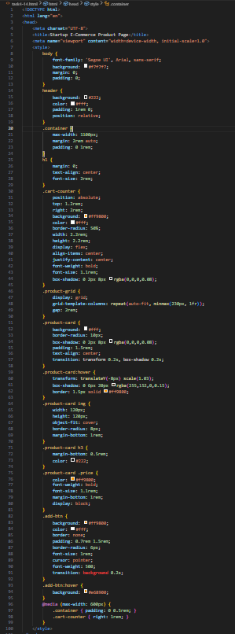
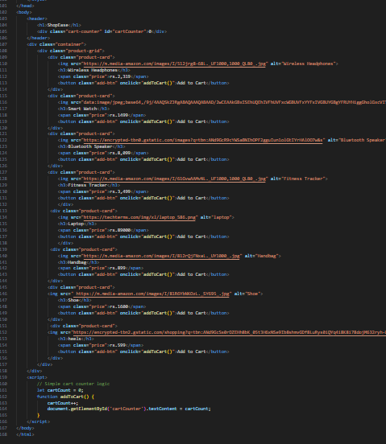

OUTPUT:
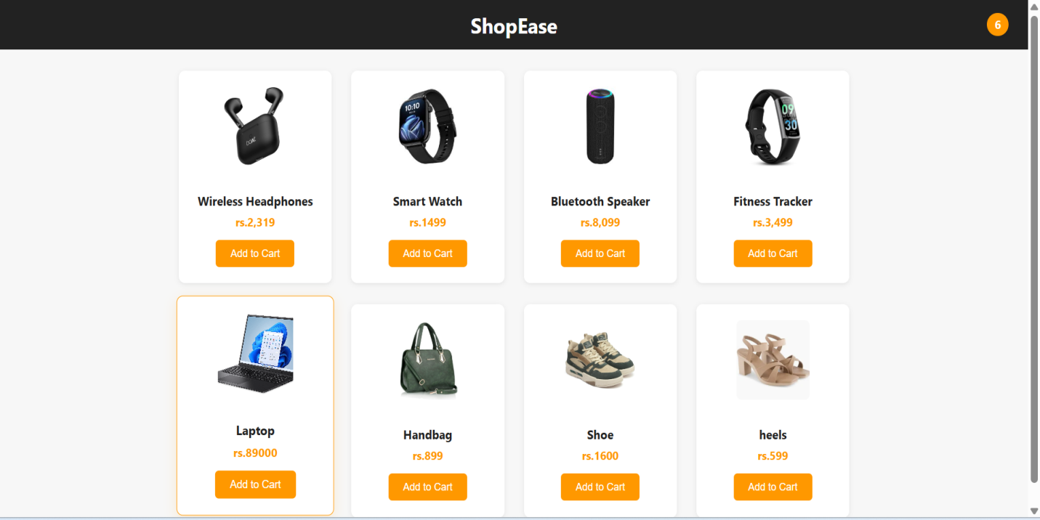

OBSERVATION:
The code creates a basic e-commerce product page using HTML, CSS, and JavaScript in a single file. It displays products in a responsive grid layout with images, names, prices, and an “Add to Cart” button. A cart counter is placed at the top-right corner inside the header and dynamically updates whenever the user clicks “Add to Cart.” The implementation is simple, lightweight, and serves as a starting point for building a full shopping cart system.

